Project Design Phase-II
Data Flow Diagram & User Stories
Date
Team ID
Project Name | Automated Network Request Management in ServiceNow
Maximum Marks | 4 Marks
Data Flow Diagrams:
A Data Flow Diagram (DFD) is a traditional visual representation of the information flows within a system. A neat and clear DFD depicts the right amount of system requirement graphically — it shows how data enters and leaves the system, what changes the information, and where data is stored.
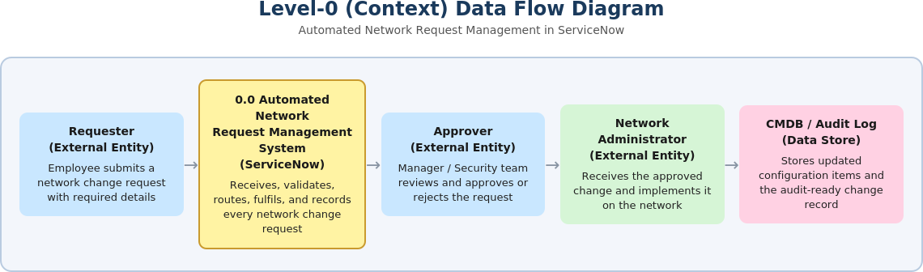
Figure 1: Level-0 (Context) Data Flow Diagram — Automated Network Request Management in ServiceNow
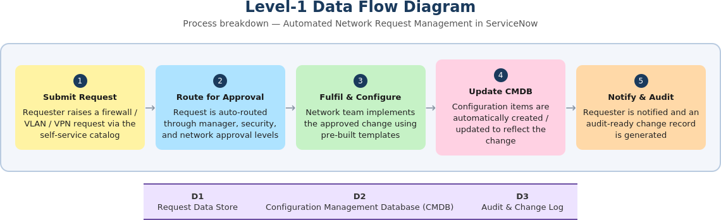
Figure 2: Level-1 Data Flow Diagram — process breakdown with data stores
User Stories
The table below lists the user stories for the Automated Network Request Management in ServiceNow solution, grouped by user type and functional requirement (epic).
User Type | Functional Requirement (Epic) | User Story Number | User Story / Task | Acceptance Criteria | Priority | Release
Requester (Employee) | Request Submission | USN-1 | As a requester, I can submit a network change request (firewall / VLAN / VPN) through the self-service catalog by entering the required details. | Request is created with a unique number and auto-routed for approval | High | Sprint-1
 |  | USN-2 | As a requester, I receive a confirmation notification once my request is submitted. | Confirmation e-mail / portal alert is received immediately | High | Sprint-1
 | Request Tracking | USN-3 | As a requester, I can track the real-time status of my request on a dashboard. | Dashboard reflects current stage: submitted, approved, in-progress, completed | Medium | Sprint-2
 |  | USN-4 | As a requester, I can attach supporting documents or diagrams to my request. | Attachments are saved and visible to approvers and the network team | Low | Sprint-2
Approver (Manager / Security) | Approval Workflow | USN-5 | As an approver, I automatically receive requests for approval based on predefined routing rules. | Request appears in my approval queue within the configured routing order | High | Sprint-1
 |  | USN-6 | As an approver, I can approve or reject a request with comments from e-mail or the ServiceNow interface. | Decision and comments are logged against the request record | High | Sprint-1
 |  | USN-7 | As an approver, I receive an automatic escalation reminder if a request is pending beyond its SLA. | Escalation notification is sent to the next approver / manager after SLA breach | Medium | Sprint-2
Network Administrator | Change Fulfilment | USN-8 | As a network administrator, I receive the approved change with all technical details pre-populated. | Change record contains complete configuration details needed for fulfilment | High | Sprint-2
 | Configuration Management | USN-9 | As a network administrator, the CMDB is automatically updated once a change is implemented. | Configuration item reflects the new state immediately after closure | High | Sprint-2
 |  | USN-10 | As a network administrator, I can generate a rollback plan template automatically for high-risk changes. | Rollback plan is attached to the change record before implementation | Medium | Sprint-3
ServiceNow Administrator | Workflow Configuration | USN-11 | As a ServiceNow administrator, I can configure approval workflows and routing rules without code changes. | New routing rule is active without requiring a platform release | Medium | Sprint-2
Compliance / Audit User | Audit & Reporting | USN-12 | As an audit user, I can generate an audit-ready report of all network changes within a date range. | Report exports with request, approval, fulfilment, and CMDB update history | High | Sprint-3

